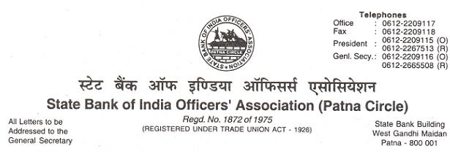
CIRCULAR NO. 11 /2018 DATE : 06.12.2018

TO,
ALL MEMBERS

UFBU CIRCULAR NO. 2018/20 DATED 30.11.2018 ON TALKS WITH IBA ON WAGE REVISION

We repreduce hereunder the text of the AIBOC Circular No. 2018/86 dated 01.12.2018, the contents of which are self-explicit.

With warm greetings,
(Ajit Kumar Mishra) GENERAL SECRETARY
OUR UNITY : ZINDABAD-ZINDABAD
S.B.I.O.A. : ZINDABAD-ZINDABAD

TEXT

Dear Comrade,

UFBU CIRCULAR NO. 2018/20 DATED 30.11.2018 ON TALKS WITH IBA ON WAGE REVISION

We reproduce hereunder our letter No. AIBOC/2018/92 dated 01.12.2018 addressed to the Convenor, UFBU on the captioned subject for your information.

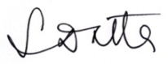
With greetings,

(Soumya Datta)
General Secretary

Text of AIBOC Letter No.2018/92 dated 01.12.2018

Shri Sanjeev K. Bandlish
Convenor, UFBU
C/o. State Bank of India
LHO Chandigarh
Plot No. 1, Sector-17A
Chandigarh – 160017.

Dear Comrade,

UFBU CIRCULAR NO. 2018/20 DATED 30.11.2018 ON TALKS WITH IBA ON WAGE REVISION

With reference to the above, we wish to point out that the captioned circular has not reflected the proceedings of the negotiation meeting with IBA on 30.11.2018 in the entirety. It has not incorporated the fact that the undersigned along with the President of AIBOC, after registering their protest, excused themselves from the meeting expressing their inability to continue the discussions further, following the IBA’s denial to offer a full and clear mandate. The content of the Circular has created confusion amongst the rank and file of our membership.

02. As the captioned circular has not correctly depicted the proceedings, we are not reproducing the UFBU circular. Instead, we will bring out a separate circular on the proceeding of the yesterday’s wage negotiation talks.

03. AIBOC Executive Committee has taken strong exception to the regressive attitude of IBA on the issue of mandate and has decided to call for a strike on 21.12.2018 demanding full and clear mandate and other related issues pertaining to the entire banking fraternity.

04. We, therefore, urge upon you to extend fraternal support to our strike call on 21.12.2018 and also assure you of our full support to all joint struggles of bank employees and officers under the banner of UFBU.

With regards,

Yours sincerely,

Sd/-
(Soumya Datta)
General Secretary

