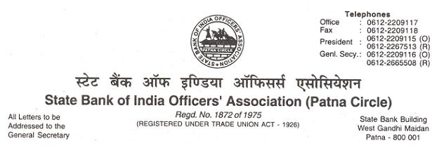
CIRCULAR NO. 10 /2018 DATE : 06.12.2018

TO,
ALL MEMBERS
AIBOC BIDS ADIEU TO COMRADE DILIP SAHA, PRESIDENT,
ON HIS SUPERANNUATION FROM THE SERVICES OF PUNJAB NATIONAL BANK

We repreduce hereunder the text of the AIBOC Circular No. 2018/84 dated 30.11.2018, the contents of which are self-explicit.

With warm greetings,
(Ajit Kumar Mishra) GENERAL SECRETARY
OUR UNITY : ZINDABAD-ZINDABAD
S.B.I.O.A. : ZINDABAD-ZINDABAD

TEXT

AIBOC BIDS ADIEU TO COMRADE DILIP SAHA, PRESIDENT,
ON HIS SUPERANNUATION FROM THE SERVICES OF PUNJAB NATIONAL BANK
Comrade Dilip Saha, President AIBOC has laid down office following his superannuation from Punjab National Bank on 30th November, 2018 after 37 years of illustrious and unblemished service career.

He joined Punjab National Bank as Management Trainee in December 1981 and became member of All India Punjab National Bank Officers’ Association (AIPNBOA) in February 1982 during the training period itself. He held various positions in the Zonal Committee of Mumbai starting from Sub Treasurer onwards since 1983. He took active part in the student union movement during his college days in Mumbai.

He became Zonal Secretary of Mumbai Zone of AIPNBOA in July 1997 and has been continuously elected for the same post for 7 terms. He was elected as Assistant General Secretary in the year 1997 to the Central Body of AIPNBOA and subsequently elected as Deputy General Secretary.

Comrade Saha became the General Secretary of AIPNBOA in the year 2012 and will continue to hold the position following his election at their Triennial Conference held on 2nd October, 2018 at Mumbai. Under his leadership, AIPNBOA has crossed its membership to 27000 becoming major unit under AIBOC, only next to AISBOF. He served a tenure from June, 2013 to June, 2016 as an Officer Director in the Board of Punjab National Bank. His achievements for the benefit of officers’ fraternity in PNB in last 6 ½ years as General Secretary is unparalleled in the entire history of AIPNBOA.

He is an accomplished expert in handling disciplinary cases. He single handedly prepared a detailed accountability policy and presented to the management. He could get the staff accountability policy of the bank replaced with the new staff accountability policy in 2013 which contains over 90% of the suggestions recommended by him.

Comrade Saha is a true militant and has always led successful agitations. He demonstrated his leadership qualities and fighting spirit during agitations in PNB. A case was filed by the PNB Management against him for organising a gherao and demonstration against the then CMD of the Bank in 2008, prohibiting the Association in Mumbai High court to hold demonstration/dharna nearer to the Branches/Offices of PNB. Subsequently, AIPNBOA won the case by dint of his strategic inputs and trade union rights were protected.

Comrade Dilip Saha has served AIBOC in different capacities and had been instrumental in drafting successive Charter of Demands. He was also one of the signatories to the 10th wage settlement. He was unanimously elected as President of AIBOC in the 11th Triennial General Council held at Jaipur on 17th to 19th March, 2017.

He played his role as President of AIBOC with élan giving space to the General Secretaries to work and at the same time provided valuable inputs. His in–depth knowledge in almost every sphere of Banking and economy and gifted with astute negotiating skills, developed over the years have played a significant role within UFBU and during ongoing wage revision talks. With him by his side, the undersigned derived immense strength and confidence during the wage negotiation talks.

The undersigned places on record the significant contribution of Comrade Dilip Saha to foster the growth and development of the Confederation during his entire tenure and especially as President. The undersigned is confident that AIBOC will continue to receive his guidance as an advisor in the days to come.

We wish him an active and long life, good health and contentment.

The undersigned in his individual capacity and on behalf of the entire membership of AIBOC conveys sincere appreciation for his colossal contribution and urge upon him to intensify his fight to safeguard the rights of common man and the banking trade unions in particular.

With greetings,

Comradely yours,

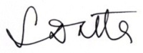

(Soumya Datta)
General Secretary

