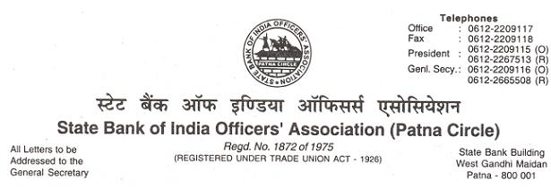
CIRCULAR NO. 09 /2018 DATE : 06.12.2018

TO,
ALL MEMBERS

COMRADE SUNIL KUMAR TAKES OVER AS CHAIRMAN OF AIBOC

We repreduce hereunder the text of the AIBOC Circular No. 2018/83 dated 28.11.2018, the contents of which are self-explicit.

With warm greetings,
(Ajit Kumar Mishra) GENERAL SECRETARY
OUR UNITY : ZINDABAD-ZINDABAD
S.B.I.O.A. : ZINDABAD-ZINDABAD

TEXT

COMRADE SUNIL KUMAR TAKES OVER AS CHAIRMAN OF AIBOC
We are delighted to inform that in the 90th Executive Committee Meeting of All India Bank Officers’ Confederation (AIBOC) held at Kolkata on 27th and 28th November, 2018, Comrade Sunil Kumar, Senior Vice President was unanimously co-opted as Chairman of the Confederation.
Comrade Sunil Kumar joined Bank of India as a Directly Recruited Officer on 16.01.1984. He post graduated in Geology; Comrade Sunil is also a Certified Associate of Indian Institute of Bankers. He was drawn to the mighty Federation of Bank of India Officers’ Association ever since he joined the Bank and was co-opted as Executive Committee Member of erstwhile Muzzafarpur Regional Council of the Association in the year 1987. He served the organisation as an Executive Committee Member for 14 long years before assuming the charge of Regional Secretary of Muzzafarpur Region on 18.01.2001.

After amalgamation of Regional Offices following organisational restructuring in Bank of India, he got elected as Deputy General Secretary of the Bihar Unit of FBOIOA in 2002 and it’s General Secretary from 01.02.2004. In recognition of his contribution to the Trade Union movement and unparalleled organisational skill, he was elected as Deputy General Secretary of the Federation in 2004. His acumen, deep understanding of the issues and compassion for the membership ensured his election as Joint General Secretary of FBOIOA in 2007, Vice President in 2010 and President in 2012. He became the General Secretary of FBOIOA after laying down of office by Comrade Harvinder Singh and leading this mighty Federation which has such a glorious and unmatched legacy of contribution in the movement of the Bank Officers’ in the country.

Comrade Sunil Kumar played a significant role in AINBOF being its Joint General Secretary in 2010, Vice President in 2012 and its President from September 2016. He is also the General Secretary of the Bihar State Unit of AINBOF from 2011 till date.

Comrade Sunil was elected in the Executive Committee of AIBOC in June 2004 and was elevated to Deputy General Secretary in January 2011, Vice President in 2012 and Sr. Vice President from the Jaipur Conference in March 2017. He was also the President of AIBOC Bihar State Unit from 2004 to 2012.

Comrade Sunil Kumar’s co-option as Chairman of the Confederation will definitely strengthen our resolute determination to carry on our ongoing struggle against merger, fractured mandate, wage revision talks based on our Charter of Demands, for ensuring proper work-life balance and to meet the challenges to carry on the legacy of the movement.

The undersigned is confident that AIBOC will emerge more militant, cohesive and determined to serve the membership drawing upon the rich repository of experience of Comrade Sunil Kumar. He also places his appreciation to the wisdom and the camaraderie of the Executive Committee for ensuring a smooth succession plan.

With vibrant greetings,

Comradely yours,
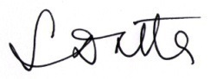

(Soumya Datta)
General Secretary

