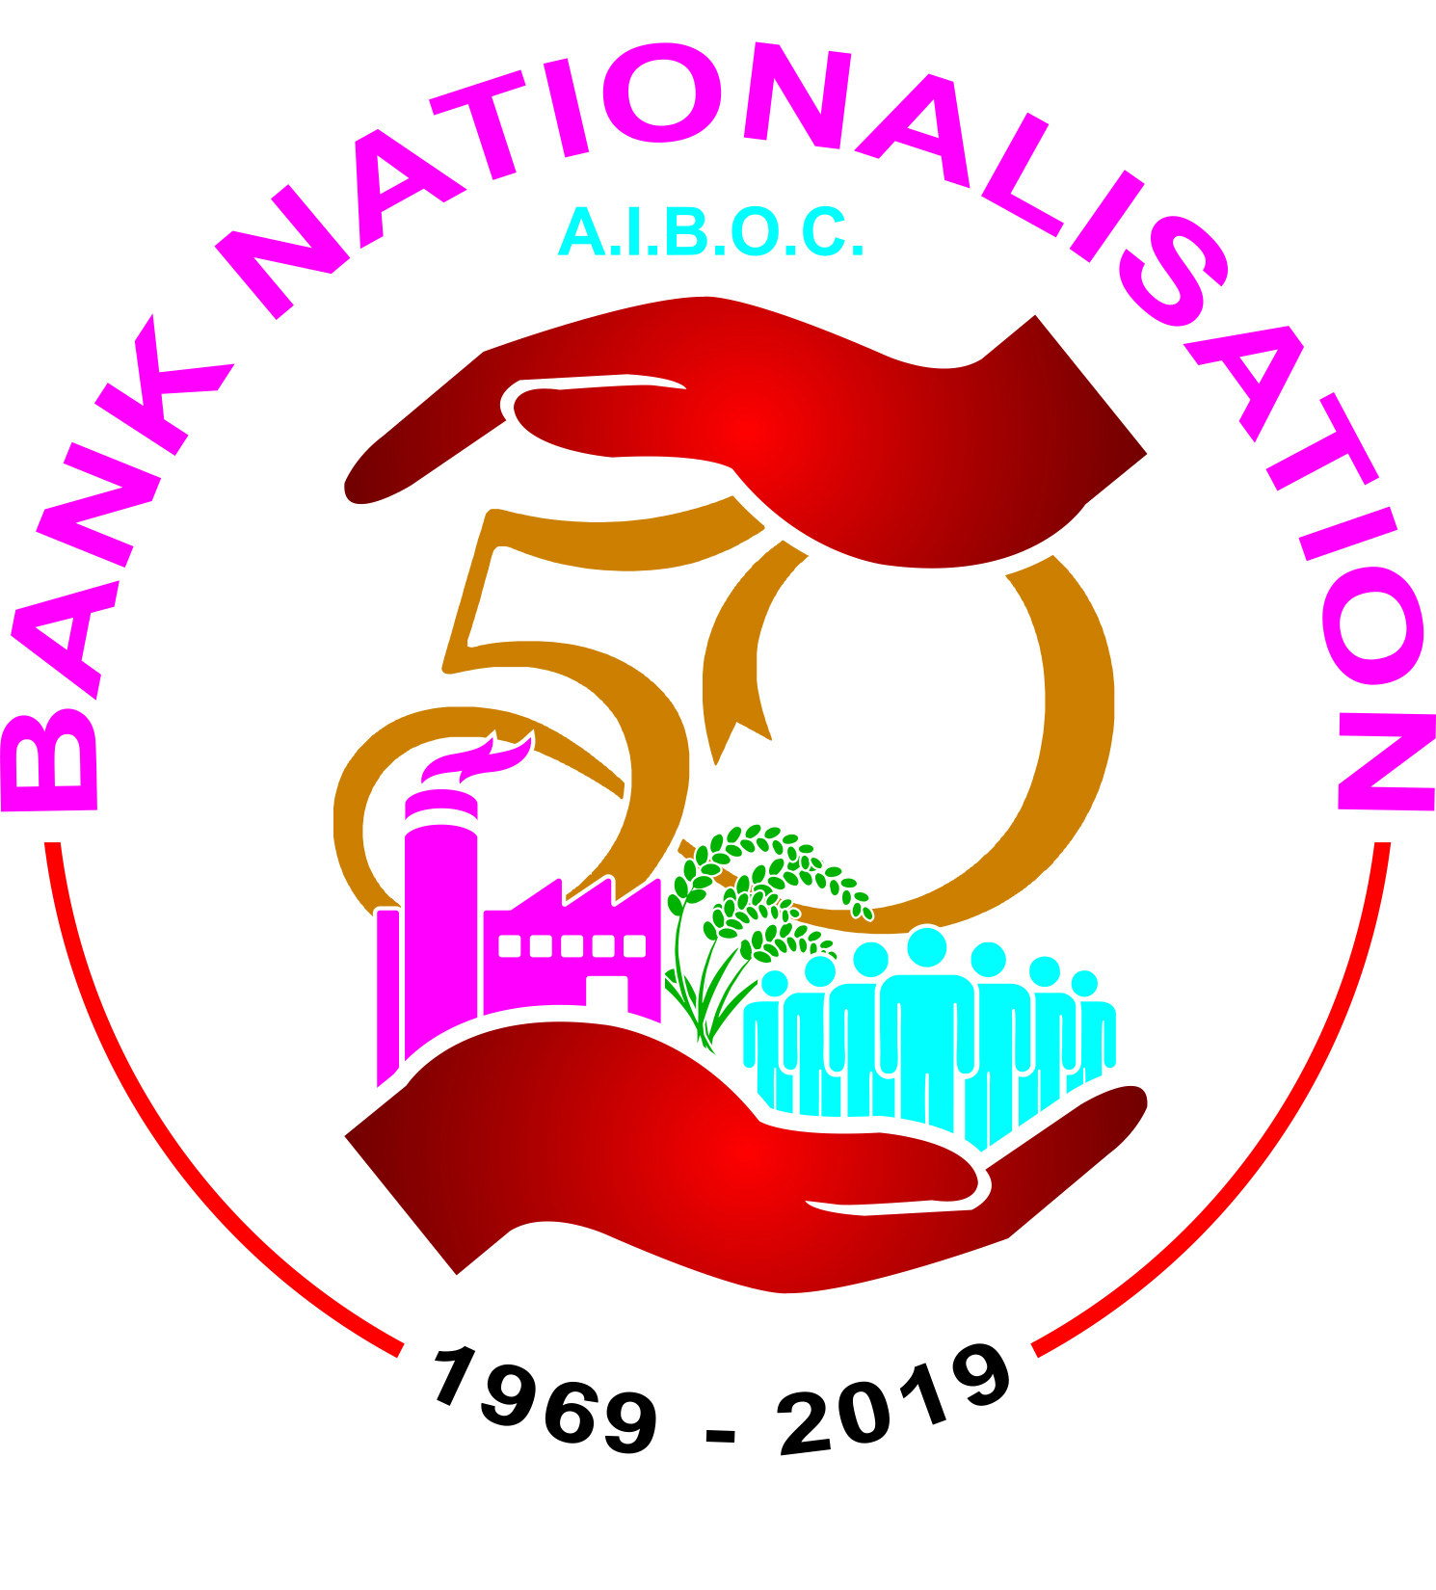
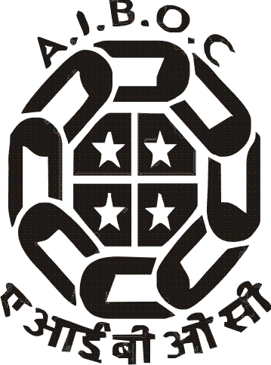
(Registered under the Trade Unions Act 1926, Registration No.3427/Delhi)
6th Floor, E-Block, Samriddhi Bhavan, 1, Strand Road, Kolkata -700 001
C/O State Bank of India Officers’ Association (Bengal Circle)
Phone: 2210-1234, Fax: (033) 2210-2210
e-mail: aiboc.sectt@gmail.com
soumyadatta.aiboc@gmail.com
website: www.aiboc.org

Ref No. AIBOC/2018/94 Date: 10.12.2018

To all the Senior Management Functionaries and Executives in the Indian Banking Industry….

Strike On 21st December 2018: Demand for Unconditional Mandate

Salutations to each and every one of you from AIBOC. We are sure that many of you were active members of the respective affiliate of AIBOC before you moved up the ladder in your career. We are writing to you at this crucial juncture when the hard earned rights which would have taken the sweat of many people including you to achieve, is now under a threat in the form of IBA’s insistence to negotiate based on the fractured mandate.

As you are aware, there is little progress in the talks for Salary Revision which is due from 01/11/2017 due to the inflexible stance of IBA. On 30th November 2018, the IBA once again declined to commit that negotiations will be upto scale VII as in the past and stated that the issue of Mandate will have to be decided by the individual Banks. However, of the 20 Public Sector Banks whom the AIBOC represents in the talks at IBA, 15 Banks have given unconditional mandate and authorized the IBA to negotiate upto scale VII. The other five Banks which have restricted the mandate upto scale III are, SBI, PNB, BOB, Union Bank of India & Indian Bank. Despite majority of the Banks giving unrestricted mandate, the IBA has taken a rigid stand that they will negotiate only upto Scale III, which clearly defies all logic. The issue has been discussed repeatedly with not only the respective Bank Managements, but with the IBA & the Government as well. AIBOC has participated in the Bi-partite talks after the Department of Financial Services, GOI, gave an assurance that the issue of mandate will be resolved.

However, now the IBA has also linked wage revision to the Performance Linked Pay based on Gross Operating Profits and Return on Assets. The proposal of Performance Linked pay given by the IBA has already been outrightly rejected by the United Forum of Bank Unions in the previous meetings with IBA. AIBOC representatives were therefore left with no other alternative but to act as per the mandate of Executive Committee and excuse themselves from further negotiations and resort to agitations followed by one day strike on 21st December 2018 as IBA refused negotiation for all scales. You may specifically note that the prime issue of the strike is the issue of unconditional mandate and the humiliating offer of hike proposed by the IBA as against our demand for Minimum wages concept to the Officers of all scales. Thus, the strike is primarily to protect the interest of all the Officers and also focus the negotiations in line with the Charter of demands submitted by us rather than hovering around petty percentages being offered during every round of negotiations.

The restricted mandate is a deliberate attempt on the part of the government and the IBA to divide the Officers on the lines of scales and to take away our hard earned rights to negotiate for the entire officer community. You may kindly recall that the negotiation up to scale VII is as per the recommendations of the Pillai Committee appointed by the Government in 1973 to study and suggest standardization of Pay scales of Bank Officers up to Scale VII with that of the Government Officers. The recommendations were accepted by the Government in 1974 and finally adopted in 1979 and since then we have been negotiating upto scale VII.

The IBA has also raised the issue of paying capacity of the Banks to offer better package or discuss on our demands listed out in Charter of demands. This being the position, the Officers in SMGS IV to TEGS VII cannot expect a better deal by falling prey to the game plan of the IBA to divide us. We have already submitted to the IBA during the negotiations that the Senior Management grade and Top Executive grade officers deserve a better deal and the only way to achieve this by adopting the formula given by us in the Charter of demands. But the IBA is strangely silent on this.

Comrade, please remember, that exploitation sets in when there is a division amongst us and it weakens our unity. Our hard earned rights are at the risk of being snatched away. Therefore, we request all of you to go down memory lane relive those days of your activism and take all actions that are possible to make this strike a grand success.

AIBOC has a principled stand that there is only one ‘Officer Community’ in the Banking Industry and for them even the ‘service regulations’ are same. Hence, there is no question of going ahead negotiating with fractured mandate thereby ridiculing the majority Banks who have adhered to the tradition and given ‘unconditional mandate’. We are not for accepting any performance linked pay either, be it for specific grades or for everyone, which will primarily put you in a precarious position. If implemented, it is certain that you would be compelled to go against your conscience to safe guard your position. It has become a common practice for the Banks to shoot off a cautionary letter to Senior Management officers and executives to desist them to join any strike. However, as per constitutional provisions any officer has the right to join any association and can therefore, take part in strikes.

We, therefore request your active support / participation in the strike on 21st December 2018 and the future calls of the Associations to protect our hard earned rights.

Your unflinching support is, of course, the essence of protecting your dignity and self-esteem.

With regards,

Yours sincerely,
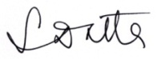

(Soumya Datta)
General Secretary

